Conference feet
For citizens of Ukraine – 10 €, for citizens of countries of the former USSR (excluding Estonia, Latvia, Lithuania) – 20 €, for citizens of other countries – 50 €. Conference fee covers conference materials, excursions and coffee breaks.
The cost of publication of one page is 2 €, for non-coauthored articles of PhD, Master and Bachelor students – 1 €.
The conference fee and cost of publication should be paid on receiving the second conference circular to Olesya Oleksiivna Bezsmertna (01032, Ukraine, Kyiv, Symon Petlura (Kominterna) Street, 1) with indication «Conference fee and payment for publication».
Application forms and articles for participation in the conference should be sent by e-mail to redbookconference@i.ua Deadline: 1 July 2010.
Contact data of the Organising Committee:
01032, Ukraine, Kyiv, Symon Petlura (Kominterna) Street, 1, O.V. Fomin Botanical Garden of the National Taras Schevchenko University of Kyiv
Tel.: +38-050-5445944 (Vice-Chair – Dr. Mykyta Peregrym); +38-044-2346056 (Reception desk of the Botanical Garden).
е-mail: redbookconference@i.ua

Second circular will be send after 1 July 2010. It will provide information about the conference program, excursions, hotels, meals etc.
NATIONAL TARAS SCHEVCHENKO UNIVERSITY of KYIV,
O.V. FOMIN BOTANICAL GARDEN
www.botany.kiev.ua 11 – 15 October 2010
www.botanic.kiev.ua Kyiv

M.G. KHOLODNY INSTITUTE OF BOTANY,
NATIONAL ACADEMY of SCIENCES of UKRAINE
UKRAINIAN BOTANICAL SOCIETY
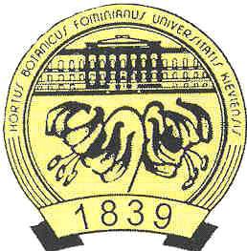
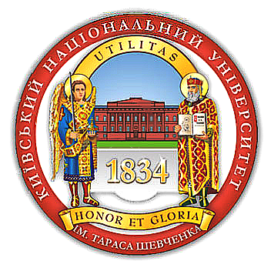
International Scientific Conference
Plant Kingdom in the Red Data Book of Ukraine: Implementation of the Global Strategy for Plant Conservation
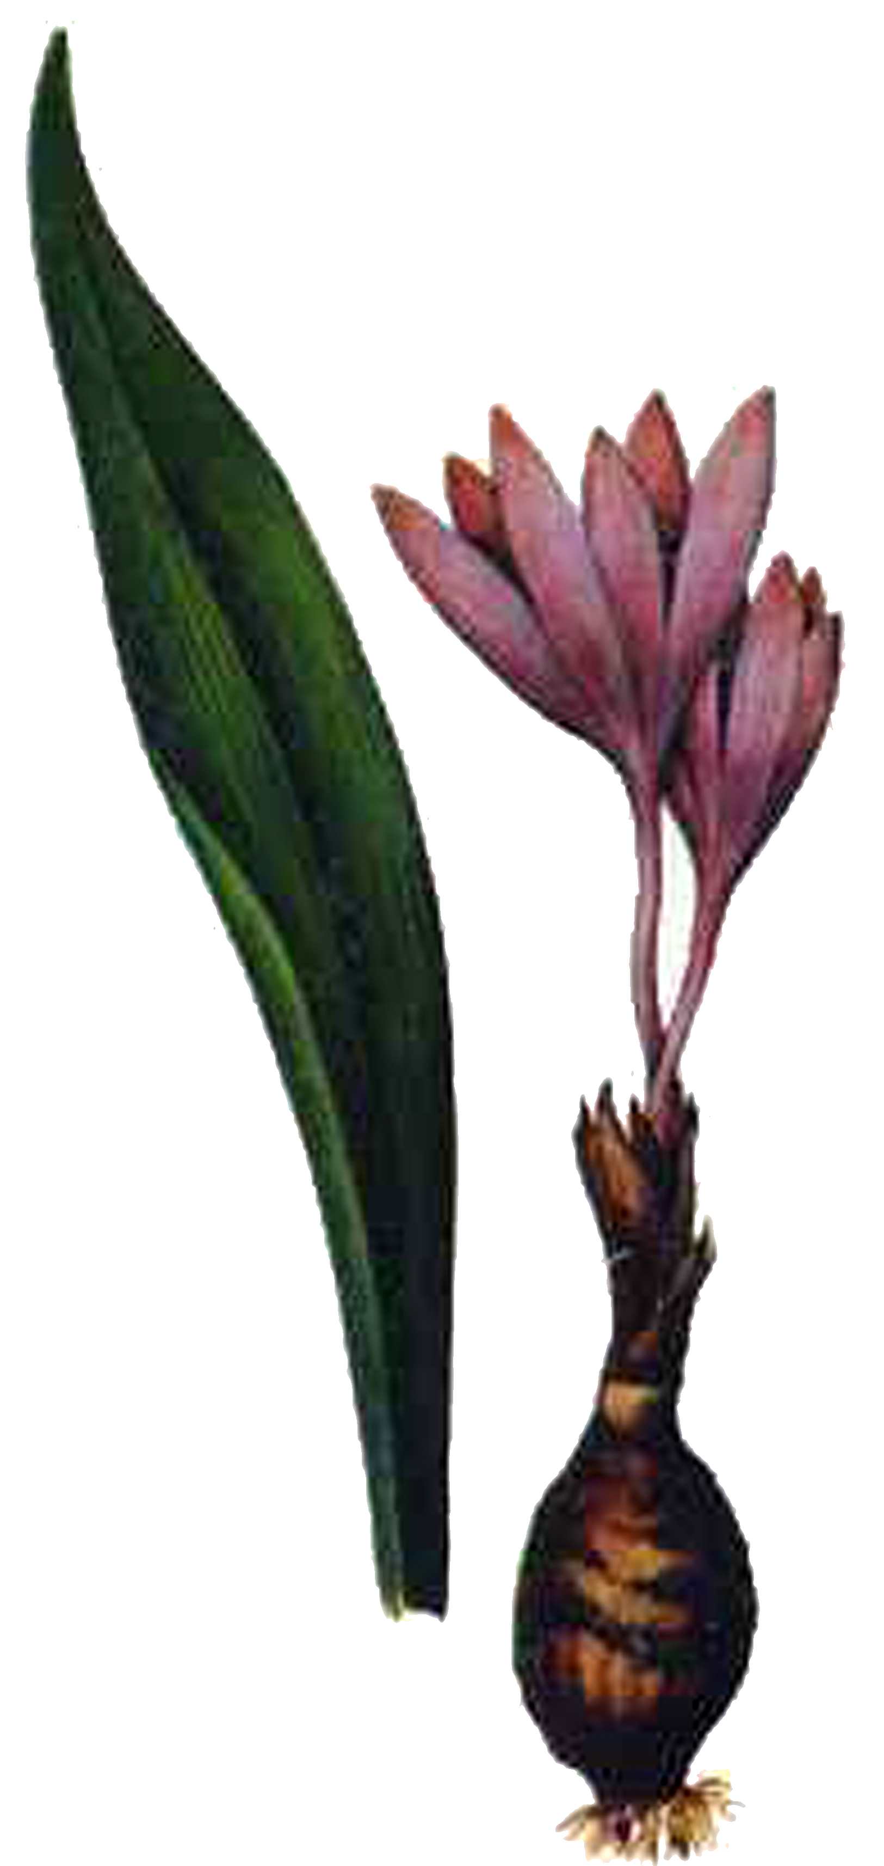Colchicum fominii Bordz.

FIRST CIRCULAR
Dear colleagues,
We would like to invite you to participate in the International Scientific Conference «Plant Kingdom in the Red Data Book of Ukraine: Implementation of the Global Strategy for Plant Conservation», which will be held 11 – 15 October 2010 in O.V. Fomin Botanical Garden of the National Taras Schevchenko University of Kyiv.
Main topic areas of the conference
1. Conceptual issues of “The Red Data Book of Ukraine. Plant Kingdom” and conservation lists of other levels.
2. Rare species of vascular plants: taxonomic, geographical, biological and ecological aspects.
3. Rare species of non-vascular plants and fungi.
4. Ex situ and in situ conservation of rare species of plants and fungi.
Additionally we are planning to organize a photo competition within the conference topic (detailed information will be provided in the Second Circular).
Conference languages
Ukrainian, Russian, English
Requirements for participation
For participation in the conference you should send the Application Form and article to the Organising Committee by the deadline of 1 July 2010. After receiving the Second Circular please pay the conference fee and cost of publication of your article, and send the copy of receipt of the money transfer to the Organising Committee.
Application Form
Please see the separate file attached to the First Circular of the conference.
Article Manuscripts: Rules and Guidelines
The Organising Committee will accept articles up to 5 pages, by e-mail. The text must be composed in Microsoft Word. The file name should consist of eight initial letters of the first author's surname. Paper format А4; right margin 1 cm, all other margins 3 cm; font Arial (9 pt); single-spaced; indent 0.5 cm. References should be cited according to the rules of the Ukrainian Botanical Journal (please see: www.botany.kiev.ua).
Example

THE GENUS TULIPA L. (LILIACEAE) IN THE FLORA OF UKRAINE

Mykyta Peregrym
O.V. Fomin Botanical Garden of the National Taras Schevchenko University of Kyiv; 01032, Ukraine, Kyiv, Symon Petlura (Kominterna) Street, 1; peregrym@ua.fm; mykyta.peregrym@gmail.com

Summary in English (not more than 500 characters, Arial, 8 pt)

Basic text, may contain tables and figures (introduction, materials and methods, results and discussion, conclusion. Separation of these parts in the text is not obligatory)

References

Attention! Your article must be supported from your department or organisation by a letter of recommendation to the Organising Committee. For independent (non-coauthored) articles of postgraduate, Master and Bachelor students should be provided with a recommendation / review of a scientific supervisor. The Organising Committee reserves the right to decline articles in cases of low scientific level, discrepancy of conference theme and format guidelines.
Organising Committee
Chairman and co-chairman: Prof., Dr. S.L. Mosyakin, Dr. V.V. Kapustyan;
Vice-chairman: Dr. M.M. Peregrym;
Members: Corr. Member of NAS of Ukraine, Prof., Dr. Ya.P. Didukh, Corr. Member of NAS of Ukraine, Prof., Dr. I.O. Dudka, Prof., Dr. V.P. Heluta, Prof., Dr. S.Ya. Kondratuyk, Prof., Dr. V.A. Solomakha, Prof., Dr. P.M. Tsarenko, Dr. M.M. Fedoronchuk, Dr. I.A. Korotchenko, Dr. V.M. Virchenko, Dr. R.M. Palagecha, Dr. V.I. Berezkina, Dr. Z.G. Bonjuk, Dr. O.V. Vascheka.

